*The Perversity of Things:*  
*Writings on Media, Tinkering, and Scientifiction*  
Hugo Gernsback

11 November 2014

# Introduction

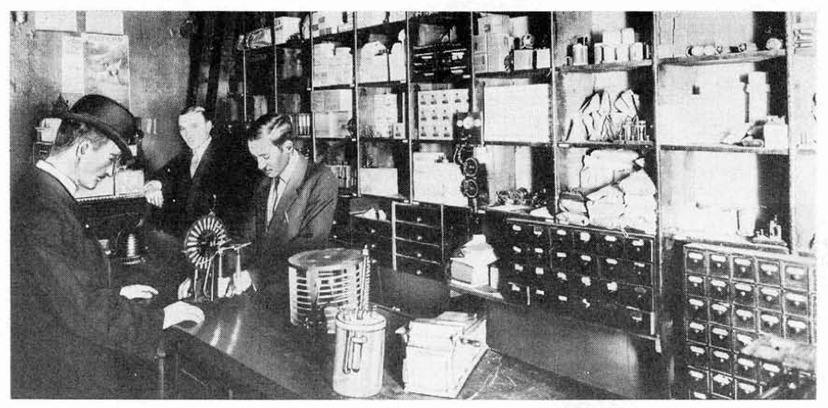

The Electro Importing Company in Manhattan, c. 1910.

It’s the summer of 1907 in downtown Manhattan and Lewis Coggeshall sits with a bucket of dimes in the back room of the Electro Importing Company’s retail store, filing them down to a coarse powder.  Sitting amid shelves of electrolytic detectors, circuit switches, dynamos, and Geissler tubes ready for sale to the city’s growing community of amateur experimenters, Coggeshall lets the filings from the dimes fall into a cardboard box at his feet.  He then measures and mixes the powder with the perfect proportion of iron (dimes were then printed on ninety percent silver). That mixture goes into a glass tube known as a coherer, one of the earliest forms of radio receiver.[1]  When a radio frequency wave comes in contact with the device, the metal filings cling together or “cohere,” allowing the signal to flow between the electrodes at either end of the tube and produce a “dot” or a “dash” in Morse code.  Coggeshall, a former telegraph operator, finally connects the coherer to a spark gap transmitter, a sending key, four dry cell batteries, and mounts them all on a wooden base.[2]  The final product is the Telimco, a portmanteau of the company’s name and one of the first fully assembled home radio sets ever sold to the American public.

Meanwhile in the offices upstairs, Coggeshall’s investment partner and the founder of the Electro Importing Company, Hugo Gernsback, writes increasingly breathless advertising copy on the Telimco, promising it to be a means of advancement for any young go-getter.  In one issue of the *Electro Importing Company Catalog*, which featured “Everything for the Experimenter” and claimed to be “the largest makers of experimental Wireless Material in the world,” Gernsback promises, “We give you the opportunity to tick yourself up to the head of a future wireless telegraph company as did Marconi, De Forest and others.”  Gernsback priced the set at $8.50 and claimed that it required no more expertise than a working knowledge of Morse code (the transmission of audio or voice was not yet possible with what was then called “wireless telegraphy”).  First advertised in the November 25, 1905 issue of *Scientific American*, the Telimco appeared thereafter every two weeks, quickly becoming one of the best selling items for sale in the Catalog.

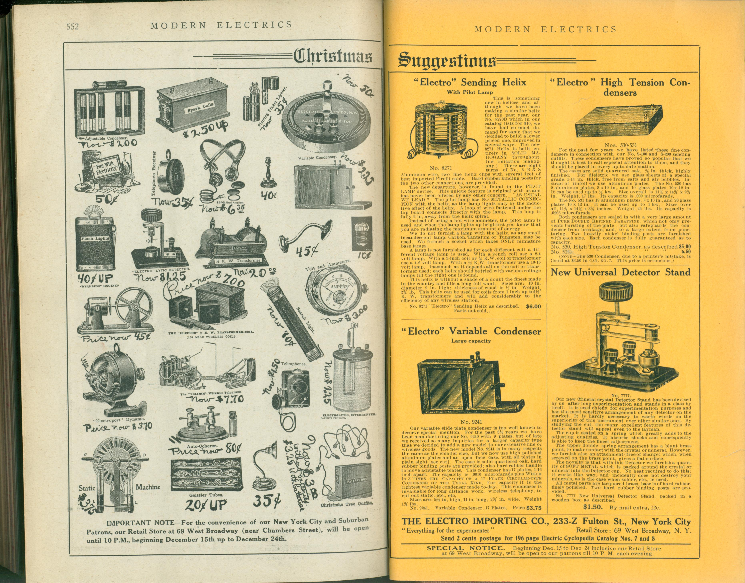

Electro Importing Company advertisement in *Modern Electrics* (1908).

But the Telimco was not exactly the revolutionary device that brought radio to the masses Gernsback later liked to claim it was.  Though its advertisements claimed the set was “guaranteed to work up to one mile,” the Telimco was notoriously finicky.[3]  As it was sold, the outfit had a range of merely 300-500 feet and could only receive signals from further distances when a large antenna was hooked up.  Further, it was highly susceptible to any kind of electrical interference, such as the elevator motor in the Electro Importing Company building, which caused difficulties during in-store demonstrations of the apparatus.  The Telimco’s untuned circuits, which would produce a high degree of interference for any nearby radio station, would be outlawed by the 1912 Radio Act.  For these reasons, its metal filings coherers “had all but disappeared from commercial work in 1910” according to historian of early radio Thomas White.[4]  From this perspective, the Telimco seems less a practical means of communication than a proof of concept for a growing group of “electrics” hobbyists.

What sort of artifact, then, is the Telimco for the historian and theorist of media technologies? Does it deserve credit for being a historical “first,” one of the earliest consumer-friendly sets that would pave the way for radio broadcasting and domestic listening in later decades? Do we overlook its technical faults, as we do the almost unplayable tin foil phonograph cylinders first released by Edison, in favor of the idea behind the prototype and what it later would become? Or do we pass it by as a marketing gimmick, a fiction, in favor of technical developments that offer more objectively measurable achievements?

Perhaps the Telimco provides a nostalgic glimpse at an era when advanced media technologies were handmade by their users, their operation still more of an alchemy than a science. Today, critical practice and the culture at large are both infused with an “affective nostalgia” in thinking about technology, in the words of Jussi Parikka. “Vintage is considered better than the new, Super-8 and 8-bit sounds are objects of not only nostalgia but also revival and retrocultures seem to be as natural a part of the digital-culture landscape as high-definition screen technology and super-fast broadband.”[5] Part of “the media-archaeological spirit of thinking the new and the old in parallel lines,” argues Parikka, involves the acknowledgement that old or “dead” media are “continuously remediated, resurfacing, finding new uses, context, adaptations.”

But what were some of the historically situated understandings of this technology? With the benefit of hindsight we can decide on the Telimco’s feasibility, significance, and what kind of historicity we want to claim for it. What we’d miss, however, is the context in which this artifact emerged. More interesting than the gap between the actual abilities and the claims surrounding the Telimco and other Electro Importing devices is the structure through which these claims were made.  Before Hugo Gernsback’s most famous publication was released in 1926—*Amazing Stories*, the first science fiction magazine—a speculative language for assessing the cultural impact of new media was introduced in the *Electro Importing Company Catalog* and refined with his technology and tinkering magazines like *Modern Electrics* (first published in 1908), *Electrical Experimenter* (1913), *Radio News* (1919), *Science & Invention* (1920), *Television* (1927), *Short-Wave Craft* (1930), and *Technocracy Review* (1933).  Regardless of how advanced the devices detailed in the pages of Gernsback’s magazines seemed—solar cells, automobile mounted radiotelephones, electric keyboards powered by vacuum tubes—his staff reported on them as if they only required a combination of already existing electrical principles and components.  These new media appeared as little more than the sum of individual building blocks that one could pick and choose from out of the pages of the *Catalog*.

Technical literacy was encouraged not only through blueprints and instruction manuals for the amateur tinkerer, but also through thought experiments and graphical projections of what these new media might look like.  This was Gernsback’s forté: reading fantastic possibilities for the future of technologically advanced societies off the shape of the most mundane of material objects, techniques and processes—even the silver filings of a dime.

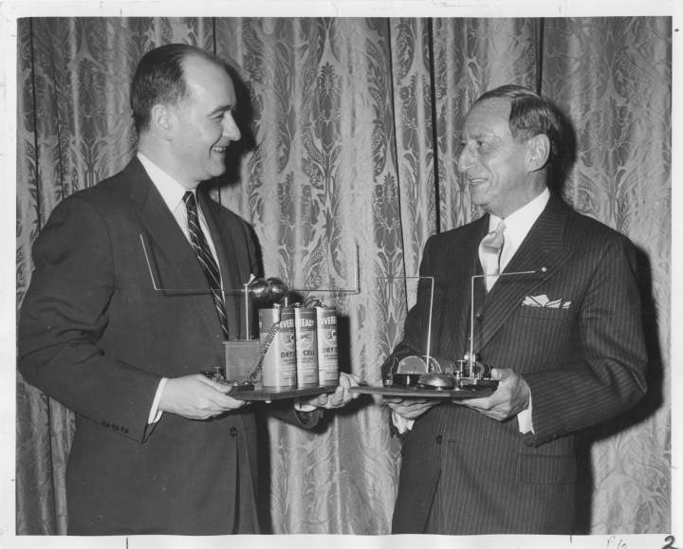

Gernsback presenting a replica of the Telimco to the Henry Ford Museum, 1957.

These amateur experimenter magazines covered not just the most spectacular and popular of the mass media, such as cinema and wireless telegraphy, but the affordances of the smallest individual components:  the selenium-coated plate, the tungsten lamp, the chromic plunge battery.  In the blueprints of *Modern Electrics* all the way through the short fiction of *Amazing Stories*, the addition and subtraction of each wire, coherer, or tuning hookup constituted a full-scale shift in the abilities and sensory affects of the apparatus being constructed as well as the narrative form through which it was described.  Moreover, these publications developed interleaving descriptive and narrative frameworks within which to describe these devices and experiences.  No longer was it sufficient to profile the technical specifications of a device or the mechanical arrangement of its parts.  Instead, magazines like *Radio News* and *Science and Invention* followed technological developments through to their most logical, and sometimes extreme, conclusions:  the increased availability of a light-sensitive alloy implied that the coming of visual telephones was near, and the number of amateurs sending in their own designs for primitive television receivers only served to confirm the immanence of this new mode of communication.

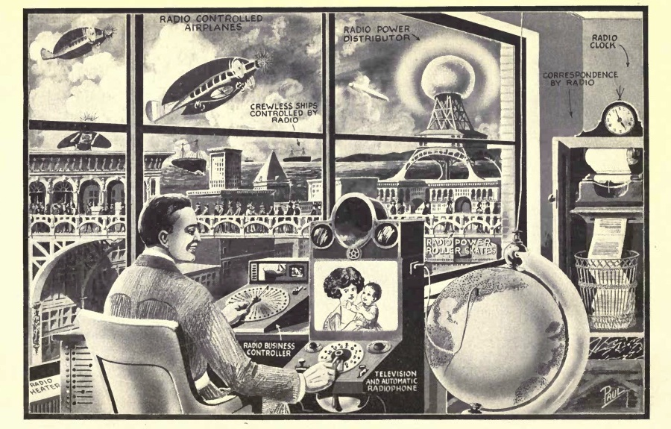

Frontispiece to Hugo Gernsback’s *Radio for All* (1922).

The Telimco was one of countless artifacts profiled in the Gernsback magazines that blurred the lines between the real and the imaginary. Part branding exercise, part rallying call to a community of active amateur experimenters, Gernsback gave names to these ideas like the Aerophone (a name for wireless audio transmission, rather than merely telegraphic code), the Telephot (an early conceptualization of the videophone), and the Hypnobioscope (an automated thought transcription and playback machine). These gadgets appeared so frequently and in such diverse contexts—as props in short stories, homemade designs in letters to the editor, and profiles of similar developments across Europe—that one gets the sense paging through the magazines that they are all part of a coherent fictional world, built up across many years and many issues. Given the pace of technological change in the early twentieth century, it seemed as if any one element of this fictional world could bleed into everyday life at any moment.

All of this began with the *Electro Importing Catalog.* Gernsback’s *Modern Electrics* began as a mail-order catalogue for imported wireless parts and exotic electrical miscellany in 1905. After several issues of the mail order catalog and a growing subscription list, *Electro Importing* began including features, editorials, and letters to the editor.  Between 1906 and 1910, the catalog grew into a series of monthly magazines for the wireless homebrewer, beginning with *Modern Electrics* in 1908 and the offshoot Experimenter Publishing Company in 1915, later expanding to a fleet of popular and specialist magazines like *Electrical Experimenter, Radio News, Science & Invention*, and the *Technocracy Review*.  The transition from the mail-order catalog to the “slick paper” monthly magazine format was a smooth one, evidenced by the fact that the third edition (1908) of the Electro Importing catalog bears the title of the new full-format magazine, “Modern Electrics.”

While *Modern Electrics* still advertised the equipment Electro Importing offered for sale in a familiar grid layout with ordering instructions, it also included feature articles detailing the latest research into experimental media technologies in America, Germany, France, and in Gernsback’s own company offices.  Regular reporters like H. Winfield Secor and René Homer, celebrity guest contributors such as Lee De Forest, Thomas Edison, and Nikola Tesla, as well as the unnamed Paris Correspondent and Berlin Correspondent provided reports on television, wireless telephony, and the use of novel electrical apparatuses in film and theatrical productions, each of which would go into a great degree of technical detail.

Though Hugo Gernsback is best remembered today for launching the first science fiction magazine, *Amazing Stories* (1926), and the Hugo Award is given out each year to the best works in the genre, he now receives little more than a one- to two-sentence nod in science fiction studies. He is associated with the gaudy covers of his magazines and a “crude and heavy-handed” editorial style that perpetuated many of the negative stereotypes still associated with science fiction today. Much of this attitude has been inherited from a generation of science fiction scholars who were not academics but editors themselves, and disparaged Gernsback’s editorial practices as well as the infamously low wages he paid his writers. But this inherited version focuses only on the period from *Amazing Stories* and after, entirely overlooking the context of the genre’s birth in Gernsback’s experimenter magazines, as well as his work as a pioneer in media technologies and broadcasting techniques.

Titled after an essay of his on the influence that objects exert on thought, *The Perversity of Things: Writings on Media, Technology, and Science Fiction* makes available texts by Gernsback that were foundational for both science fiction and the emergence of media studies. These editorials, speculative blueprints, literary critical essays, and media histories have been out of print since their original publication in Gernsback’s magazines from 1905-1933. Together, they show how his publications evolved from an electrical parts catalog into a fully-fledged literary genre, an altogether untold story in American literary and media history. As the curator of a [recent exhibit](http://on1.zkm.de/zkm/stories/storyReader%248492) on Gernsback at the ZKM (Center for Art and Media Technology), Franz Pichler writes, “Hugo Gernsback is the father of American electronic culture.”[6] With his monthly editorials, feature articles, and short fiction, Gernsback pioneered a kind of writing that combined hard technical description with an openness to the fantastic. It was a mixture out of which an entire literary genre emerged to tackle the question of the distinctive specificity of “medium” in a new wireless age in the opening decades of the twentieth century. *The Perversity of Things* will show that science fiction emerged in the United States as a discourse on media.

# Background

## Gernsback’s biography

Born Hugo Gernsbacher in Luxembourg in 1884, the son of a successful wine wholesaler, Gernsback immigrated to the United States in 1904 at the age of 19. Carrying with him the design for a new kind of dry cell battery, Gernsback published his first article on the device a year later in *Scientific American* under that most American of names, “Huck.” Gernsback sold the battery patent to the Packard Motor Car Company, who ended up using technology in their ignition systems. With the profits of his sale, Gernsback formed the Electro Importing Company, an importer of specialized electrical equipment from Europe and the first mail-order radio house in the country. Through their catalog and retail store at 84 West Broadway in New York, the company provided access to specialized wireless and electrical equipment not found anywhere outside of Europe. Electro Importing catered to a diverse clientele, providing their more advanced basement experimenters with the first vacuum tube offered for sale to the general public in 1911, and manufacturing for their novice users in 1905 the first ever fully assembled radio set commercially available in the United States, the Telimco.



Electro Importing Company store, c. 1908.

After several issues of their mail order catalog and a growing subscription list, Electro Importing began including features, editorials, and letters to the editor. Between 1906 and 1910, the catalog grew into a series of monthly magazines for the wireless homebrewer, beginning with *Modern Electrics* in 1908 and the offshoot Experimenter Publishing Company in 1915. While *Modern Electrics* still advertised the equipment Electro Importing offered for sale in a familiar grid layout with ordering instructions, it also included feature articles detailing the latest research into experimental media technologies in America, Germany, France, and in Gernsback’s own company offices. Regular reporters and celebrity guest contributors like Lee De Forest, Thomas Edison, and Nikola Tesla.[7] provided reports on television, wireless telephony, and the use of novel electrical apparatuses in film and theatrical productions, each of which would go into a great degree of technical detail.

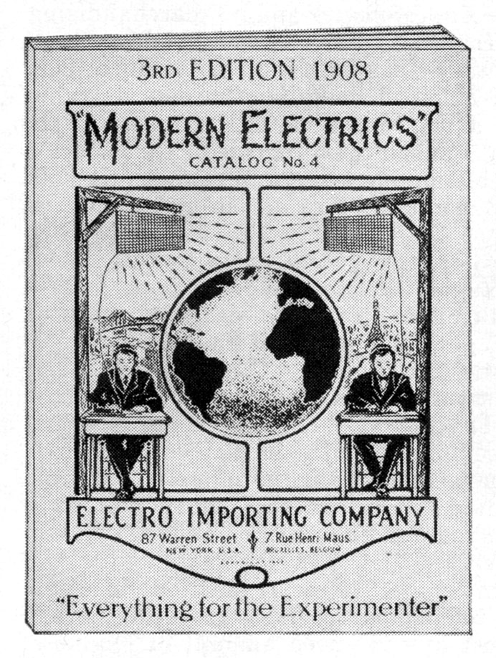

Modern Electrics in its original catalog form, 1908.

But the hallmark of the magazine became its more speculative articles, those that were willing to extrapolate fantastic scenarios out of the technical details at hand. In “Signaling to Mars,” Gernsback detailed the conditions that would have to obtain in order for Earth to send messages via wireless telegraph to the red planet. The quantitative description of the transmitting apparatus in terms of its necessary output (70,000 kilowatts) and best time of year to signal (summer) only constitutes one aspect of this scenario.  Gernsback goes on to take into account the nature of Martian intelligence that would be necessary for such a communicative circuit to be completed:  “we can only hope that the Martians are further advanced than we and may signal back to us, using a method new to us and possibly long discarded by them, when thousands of years ago they stopped signaling to us, and gave us up, as we did not have intelligence enough to understand.”[8]  Continuing in the tradition of Percival Lowell and William Henry Pickering—the latter of whom offered a similar proposal on the front page of *The New York Times* to communicate with Mars using a series of mirrors[9]—the supposition of Martian technology (or biology, or ecology) provided a topos upon which readers might asses the direction of its terrestrial analogues.

For readers of *Modern Electrics*, the technical context in which this highly speculative article appeared only led credence to the idea that contact with an alien civilization was right around the corner. In the copy of this issue at Princeton University’s Firestone Library, someone inserted a newspaper clipping (now a permanently affixed leaf within the bound volume) that tells of a new distance record for wireless signaling, from San Francisco to the Pacific Mail Line steamship Korea as it made its way across the ocean. Left there as if to vouch for the plausibility of the idea that we’ll soon be able to connect with our nearest planetary neighbor, the clipping provides a wonderful sense of how it was people read these magazines.[10] Though the Gernsback titles eventually became infamous for their sometimes outlandish claims – that electric current might clean us better than water; that the success of a marriage can be predicted using gadgets assembled out of various household supplies – they were always presented through a lens of supposedly scientific rationality. This frame affected the reception of the magazines by their readers, the design ethos that grew up around them, and the kind of fiction they eventually produced.

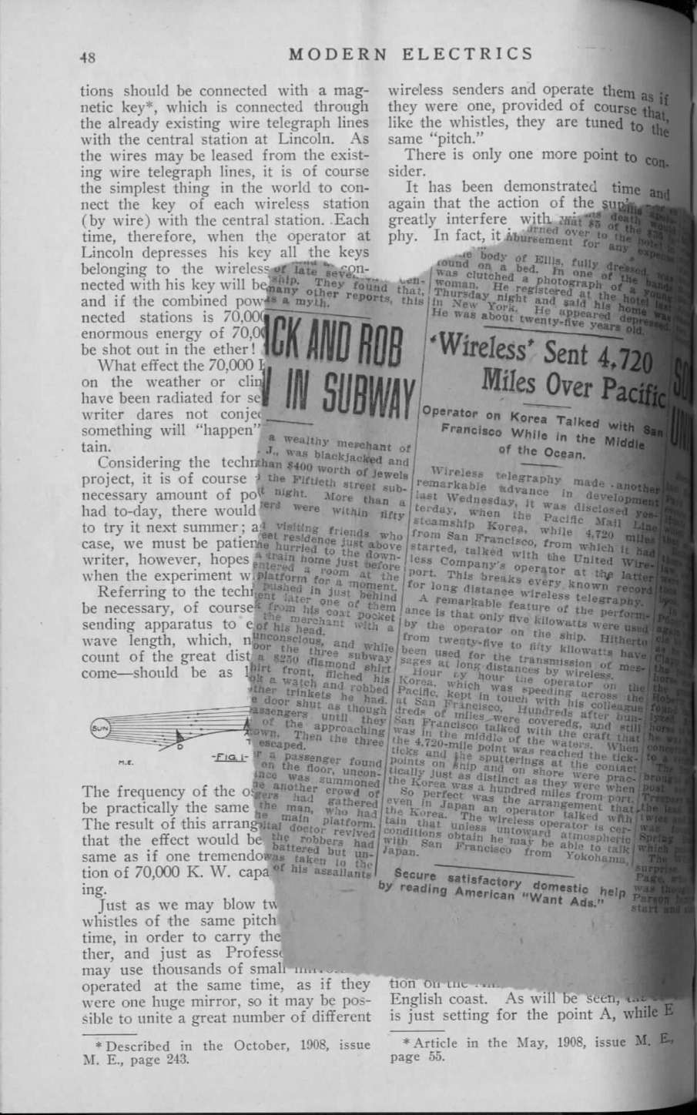

The shape of media to come took on an iconography all its own through the illustrations of Frank R. Paul. Paul’s depictions of gadgetry circulated widely beyond their original publication venues in a way that has never before been given any attention. Plans for the osophon, a device Gernsback designed to replace headphones by transmitting sound through vibrations in the jawbone of the listener, were published and reviewed in the German journal *Der Radio-Amateur*.[11] Paul’s sketch of a man using a tuning fork to calibrate the speed of the 1928 *Science and Invention* Nipkow disk television receiver was republished the following year in the Chinese film journal *Yingxi zazhi* (*Shadow Play Magazine*) as an illustration of recent research into television, what was referred to in the article as, directly translated, “wireless cinema.”[12] Paul’s images, now in the public domain, accompanied Gernsback’s writings and will form an important part of this collection as well.

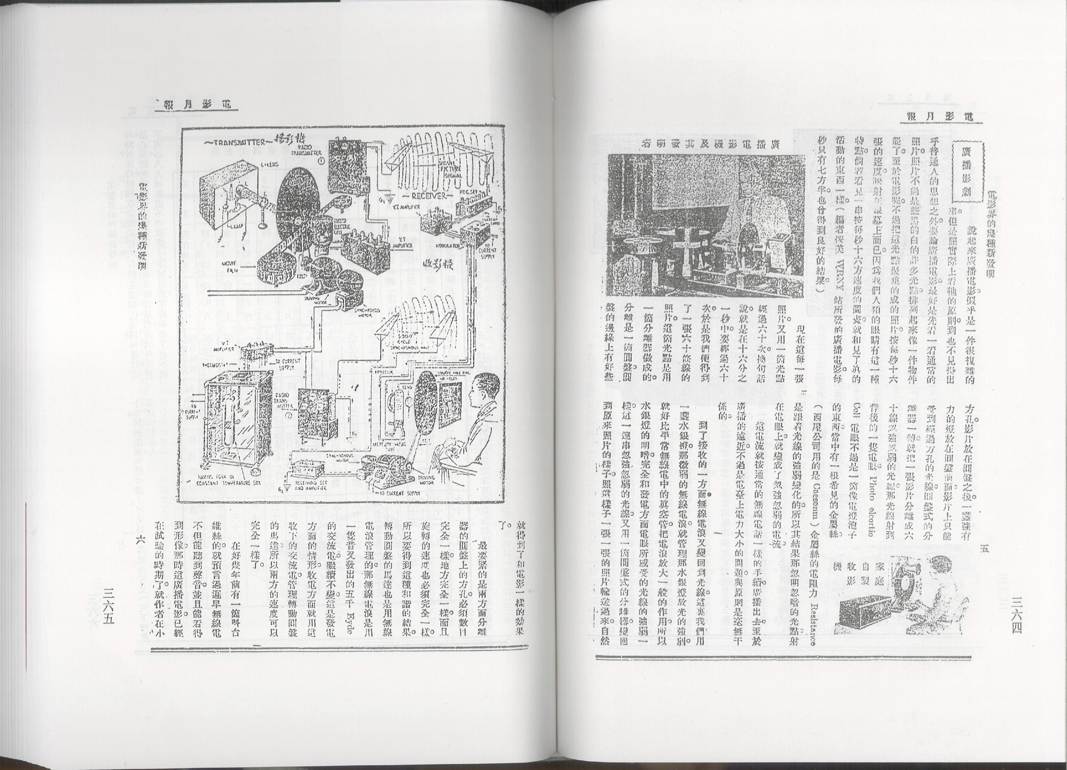

*Science and Invention* illustrations republished in Chinese film journal *Yingxi Zazhi*.

The incredibly rich context of the science fiction’s birth in Gernsback’s fleet of technical publications for the amateur experimenter, as well as his work as a pioneer in media technologies and broadcasting techniques, have been entirely overlooked. In his illustrated magazines and compendiums of amateur designs, one could find a literary treatise on what the genre of “scientifiction” should look like alongside blueprints for a homebrewed television receiver well before its commercial possibility. Gernsback’s translation of an influential German handbook titled *The Practical Electrician* ran next to a speculative article on what it would take to provide a global system of free electricity powered by ocean currents. Long before Gernsback founded *Amazing Stories,* these magazines used speculative fiction to find a language suited to the analysis of emerging media like radio, television, or the more exotic osophone and telegraphone.

*The Perversity of Things* thus seeks to provide a reappraisal of both the “hard” technical roots of American science fiction and the highly speculative orientation toward media technologies during this period. Science fiction in its early days wasn’t just a literary form, it was a mode of interacting with new media. The literary historical gambit of this book is to recover the radical sense of openness that greeted not only the basement tinkerer working through the feasibility of transmitting images over a wire, but also the author of “scientifiction” stories who possessed a highly sophisticated awareness of the fact that “Two hundred years ago, stories of this kind were not possible.” Often, these individuals were one and the same, weaving together functional and fictional devices in a manner that served for them as a form of scientific discovery in itself.

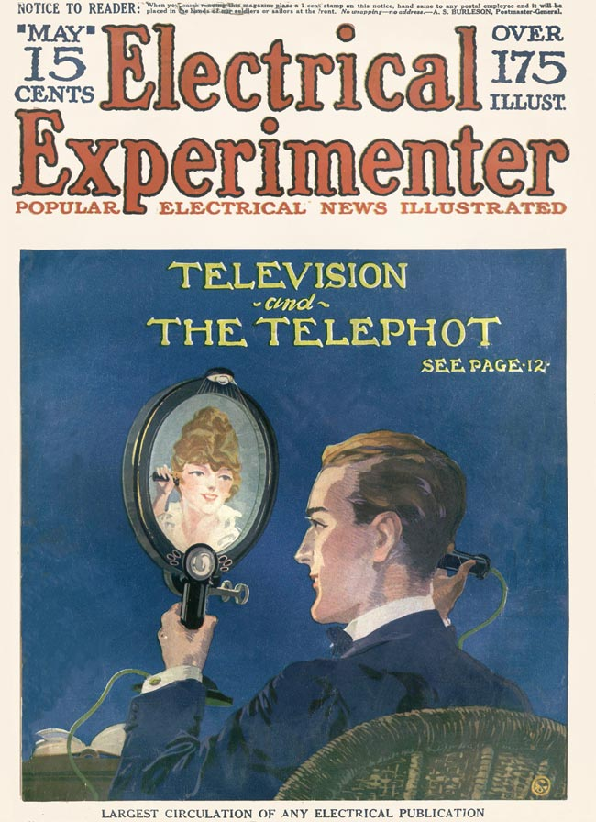

*Electrical Experimenter*, May 1918.

## Gernsback’s reputation in the critical literature

Hugo Gernsback has been given very little attention in science fiction studies, with the field’s leading critics often assuming that *Amazing Stories* was little more than a marketing gimmick for Gernsback’s technical ventures. The fiction published in the pages of his magazines is often seen to have very little aesthetic or literary value. So when Gernsback is given credit in the foundation of modern American SF, it is as a kind of marketer of a new brand name, rather than a writer or editor. As Alexi and Cory Panshin write, “In the pages of *Amazing*, SF literature at last became identified by a single name: ‘scientifiction.’ It was provided with a history. It was defined and demonstrated. It was consolidated and unified. In *Amazing*, SF became conscious of itself.”[13] According to John Clute and Peter Nicholls, Gernsback “gave the genre a local habitation and a name,” and for James Gunn, he “provided a focus for enthusiasm, for publication, for development,” and bestowed science fiction with its “characteristic content, a characteristic form, and characteristic purposes.”[14]

These critical histories (each of which are written by SF novelists in their own right) proceed as if propelled by their own fantastic, alternate history: what if science fiction left us with texts as highly valued as the works of modernism from the very beginning? No doubt the field of science fiction studies has done a great deal of work in order to elevate certain works of the genre (mainly from the 1960s and 70s New Wave) to a kind of academic respectability. But these assumptions about the genre’s magazine era beginnings have never been questioned, nor have any of Gernsback’s publications save for *Amazing Stories* been submitted to any kind of rigorous analysis. The editorial function many SF histories begrudgingly ascribe to Gernsback overlooks the much more interesting heritage of magazine SF within a wider tradition of thinking about new media.

# Recent attention

This story has held sway over the reception of Gernsback until very recently. But the need for this volume is now becoming apparent as we experience technological revolutions in the fabric of the everyday similar to those that brought readers to the Gernsback publications a century ago. The ability of Gernsback’s ideas to speak to us today can be seen in the ways that images from his magazines circulate online through a wide variety of social image sharing sites and blogs, like Reddit, Tumblr, and the Scientific American blog *Paleofuture*. Gernsback’s life and works are now beginning to receive a more formal treatment as well, with two major museum exhibits recently held: one at Luxembourg’s [National Center for Literature](http://www.cnl.public.lu/agenda/2011/5/Expo_Hugo_Gernsback/index.html?highlight=gernsback) in 2011, and another in 2013 at the [ZKM (Center for Art and Media Technology)](http://on1.zkm.de/zkm/stories/storyReader8492) in Karlsruhe, curated by Franz Pichler and the media theorist Peter Weibel.[15] In addition, the visual artist Eric Schockmel is currently developing an animated documentary film about Gernsback.

# Outline of Book

My introduction to this volume will situate Gernsback’s writings within their technological and media historical contexts. The essays will then be organized chronologically in order to highlight the conceptual fluidity of Gernsback’s writings and allow readers to experience the interdisciplinary soup out of which his thinking emerged. For instance, one essay covers the chemical properties of selenium as a substrate for electrically transmitted images, while the next seeks to recover a forgotten nineteenth century dime novel author, or comment on the latest federal legislation on wireless telegraph regulations. Though these topics seem very disparate to us today, they emerged as part of the same epistemological endeavor. Ordering the essays chronologically allows us to preserve this context.

A thematic index will provide a further entry point for readers interested in particular aspects of Gernsback’s thinking. Each of these five sections (which will organize the book’s introductory essay as well) are explained below.

## Scientifiction

*Foundational writings on science fiction as a distinct genre, including literary historical essays on writers Gernsback understood to be predecessors: Wells, Verne, Poe, Luis Senarens, Clement Fezandié.*

Today, the phrase “science fiction” conjures up images of bug-eyed monsters, ray guns, starships, and sonic screwdrivers. But in the opening decades of the twentieth century, before a century’s accretion of images, narratives, and clichés, that which was not yet called science fiction consisted of a great number of concrete practices all geared toward a reckoning with the technological revolutions in the fabric of everyday life. “Science,” wrote Gernsback in the inaugural issue of *Amazing Stories*,

through its various branches of mechanics, astronomy, etc., enters so intimately into all our lives today, and we are so much immersed in this science, that we have become rather prone to take new inventions and discoveries for granted. Our entire mode of living has been changed with the present progress, and it is little wonder, therefore, that many fantastic situations […] are brought about today. It is in these situations that the new romancers find their great inspiration. (“A New Sort of Magazine)

As early as 1915, Gernsback cites nineteenth century dime novels like *Deadwood Dick* and authors like Luis Senarens (“The American Jules Verne”), revealing an awareness of the genealogy of science fiction over a decade before the launch of *Amazing Stories* in 1926, when most SF critics locate the birth of the genre. These essays make clear that a very sophisticated understanding of the genre’s roots was already in place by the 1910s, and that science fiction as we understand it today was a rich and variegated series of activities, rather than merely a literary form.

## Tinkering and technology

*Reports on broadcast experiments at Gernsback’s WRNY radio station, new inventions developed at the Electro Importing Company labs, and critical essays on techniques for thinking creatively through technology.*

Gernsback oversaw experiments with broadcast media and the effects of various instruments and signal processing techniques on the auditory perception of the station’s listeners from his radio station WRNY. Several articles and editorials cover these experiments, including a concert broadcasting some of some of the earliest electronic instruments developed at the E.I. Company offices (“The Pianorad”) as well as one of the earliest television broadcasts on record, using a unique method of interleaving audio and visual signals across a single frequency (“Television and the Telephot”). Gernsback championed the creativity and problem-solving abilities of the tinkerer throughout his career (“Why the Radio Set Builder”; “Is Radio at a Standstill?”)

While conducting these groundbreaking experiments, Gernsback kept these developments open to the contributions and participation of his readers. In one editorial for *Radio News*, (“Television to the Front”) Gernsback describes the television as just a simple add-on or expansion kit to a normal domestic radio set. “I am quite certain that the final television apparatus on your radio set will take up no more room than your present cone speaker.” Regardless of how advanced the devices detailed in the pages of Gernsback’s magazines seemed—solar cells, automobile mounted radiotelephones, electric keyboards powered by vacuum tubes—his staff reported on them as if they only required a combination of already existing electrical principles and components. These new media appear as little more than the sum of individual building blocks that one can pick and choose from out of the pages of the *Electro Importing Catalog*.

## Media history

*Later works that read current inventions in light of their not so distant precursors, profiling forgotten (and often quirky) paths not taken in the development of radio and television.*

In Gernsback’s editorials, media history is evoked not merely as a nostalgic trip back to the devices of yesteryear, as it often is today in retro-kitsch, but as an archive of possibilities ripe for future experimentation. For instance, in a 1927 editorial (“Radio Steps Out”), at a moment when national broadcast networks were flickering to life and music and variety programs were flooding the country, the medium of radio had become a fixed idea in people’s minds that papered over the inherent abilities of the underlying technology. Looking back on that strange trajectory in which the technology underlying wireless telegraphy became “radio,” an everyday part of household furniture, Gernsback writes, “the public at large is not aware of the fact that the art of radio is used for hundreds of different purposes aside from broadcasting and telegraphy. … There is hardly any industry today that cannot make use of radio instruments in some phase of its work.”

His examples range from a force-field like burglar alarm, to automating the recording of lightning strikes, from measuring the minute weight and touch of a fly to scanning factory workers for stolen metals. And, in a forgotten example of Gernsback’s own from the 1900s (which he christened the “Dynamophone”) electric motors can be started remotely by the human voice, proving that “the apparatus foreshadowed broadcasting: the human voice actually did create effects at the receiving end,” both for machines and humans. Gernsback consistently reminds us that the inherent abilities of wireless, i.e. of information transmitted through the air, has now itself been scattered by the winds of technological evolution and inflects our understanding of and interaction with a fantastic number of techniques, technologies, and media.

## Broadcast regulation

*Activism, community organization, and manifestos written in service of radio amateur rights after the US government banned all public wireless activities in the wake of World War I; includes later writings for the Technocracy movement.*

With the outbreak of World War I, the U.S. Navy outlawed all amateur wireless broadcasting activities and took sole control of the airwaves. *Modern Electrics* thus became a community forum for frustrations over this policy, as well as a drawing board for what broadcast regulation should look like once the war was over. Gernsback and his associates formed “The Wireless Association of America” in 1910, an education and outreach organization that ended up training many of the wireless operators that the Navy would need once the U.S. entered the war, one of who even developed a means of recording clandestine German U-boat commands that were being relayed through a New Jersey wireless station, unbeknownst to the U.S. Government (“Sayville”). As Gernsback liked to proudly claim later in life, language from his *Modern Electrics* editorial on broadcast regulation (“The Alexander Wireless Bill”) was eventually taken up by the Congress’s Wireless Act of 1912. Finally, as Tim Wu writes, *Radio News* later served as one of the first broadcast programming guides in the country’s history, publishing lists of each radio station in operation, along with their frequencies and “what one might expect to hear on them – a forerunner of the once hugely profitable *TV Guide.*”[16]

Gernsback would later re-enter policy debates and the politics of technology with his short-lived *Technocracy Review,* which featured essays by the leaders of the Technocracy, Inc. movement. People like Howard Scott argued that a small elite of technologically-inclined leaders, by dint of their mathematical and engineering expertise, would be able to govern the country more rationally, economically, and fairly. Gernsback’s editorials for this magazine provide an overview of the idea as it gained currency after the stock market crash (“The Machine and the Depression”).

## Selected fiction

*Four short stories and the original serialized version of the famous* Ralph 124C 41+, *all of which have been out of print since their original magazine publication.*

While editions of Gernsback’s *Ralph 124C 41+* have been republished in 1950, 1958, and 2000, all of these use a revised version of the text Gernsback updated in 1929. The original, serial version from 1911 has not been seen since its original magazine print run. There are significant differences between these two versions of the novel that deserve to be looked at by a wider audience.

Other short stories by Gernsback that have not been reprinted include “New York A.D. 2660” (1911), “The Magnetic Storm” (1918), “The Electric Duel” (1927), and “The Killing Flash” (1929). As mentioned above, the speculative mode of these fictions is not out of step with the technical articles they were published alongside. Including them within the continuum of essays on broadcast regulation and tinkering allows them to be experienced in a context similar to their original intentions.

# Specifications and Audience

This volume has the potential for broad-based appeal to both academic and popular audiences. A scant few works of scholarship have been devoted to this period in the history of science fiction, and it is my hope that the availability of these texts can significantly revise our understanding of the genre’s origins in **science fiction studies**. Because Gernsback’s writings explore many branching paths not taken in the history of media technologies, this book will be useful for **media studies** as well, a field increasingly interested in the “archaeology” of dead, hybrid, and imaginary media. In **design studies**, where “design fiction” and “speculative design” are becoming vibrant fields of inquiry, a book surveying the prehistory of thinking critically about the future of everyday objects would prove a valuable resource. These essays can find an audience outside of academia as well, as they were inherently meant to be read by a **popular audience** without sacrificing the sophistication of their ideas. The flurry of recent activity around critical making, maker spaces, 3D printing and rapid prototyping provides yet another occasion for this book’s publication.

# Bibliography

Bao, Weihong. “Sympathetic Vibrations: Hypnotism, Wireless Cinema, and the Invention of Intermedia Spectatorship in 1920s China.” In. Columbia University, New York, 2011.

Clute, John, and Peter Nicholls. *The Encyclopedia of Science Fiction*. St. Martin’s Griffin, 1995.

Gernsback, Hugo. “Radio Movie.” *Science and Invention* 16, no. 7 (November 1928): 622–623.

———. “Signaling to Mars.” *Modern Electrics* 2, no. 2 (1909): 49.

Gunn, James E. *Alternate Worlds: the Illustrated History of Science Fiction*. [New York, N.Y.?]: A & W Visual Library, 1975.

Lee, Thomas H. “A Nonlinear History of Radio.” In *The Design of CMOS Radio-Frequency Integrated Circuits*. Cambridge University Press, 2004.

Nesper, Eugen. “Das Osophon von H. Gernsback.” *Der Radio-Amateur* 2, no. 1 (1924): 10.

Panshin, Alexi, and Cory Panshin. *The World Beyond the Hill: Science Fiction and the Quest for Transcendence*. Los Angeles: Jeremy P. Tarcher, Inc, 1989.

Parikka, Jussi. *What Is Media Archaeology?* Cambridge, UK; Malden, MA: Polity Press, 2012.

Pichler, Franz. *Hugo Gernsback Und Seine Technischen Magazine*. Linz: Rudolf Trauner Verlag, 2013.

“Planned Messages to Mars.” *The New York Times* (April 1909): 1.

Shen, Xiaose. “Dianyingjie de Jiizhong Xin Faming [Several New Inventions in the Film World].” *Dianying Yuebao* 9 (1929): 1–64.

“Telimco Wireless Telegraph.” *Radio Museum* (2002). <http://www.radiomuseum.org/r/electro_im_telimco_wireless_telegraph.html>.

Tesla, Nikola, and Samantha Hunt. *My Inventions and Other Writings*. Penguin Classic, 2011.

White, Thomas H. “Pioneering Amateurs.” *United States Early Radio History*, 1996. <http://earlyradiohistory.us/1910ei.htm>.

“Wireless Telegraph [Advertisement].” *Scientific American* (November 1905): 85.

Wu, Tim. *The Master Switch: The Rise and Fall of Information Empires*. Knopf Doubleday Publishing Group, 2010.

1. Marconi’s original coherer design called for nineteen parts nickel to one part silver. Receiving the strongest signals involved a degree of culinary improvisation, so to speak. Thomas H. Lee, “A Nonlinear History of Radio,” in *The Design of CMOS Radio-Frequency Integrated Circuits* (Cambridge University Press, 2004), p. 4.
2. “Telimco Wireless Telegraph,” *Radio Museum* (2002), <http://www.radiomuseum.org/r/electro_im_telimco_wireless_telegraph.html>
3. “Wireless Telegraph [Advertisement],” *Scientific American* (November 1905): 85
4. Thomas H. White, “Pioneering Amateurs,” *United States Early Radio History*, 1996, <http://earlyradiohistory.us/1910ei.htm>
5. Jussi Parikka, *What Is Media Archaeology?* (Cambridge, UK; Malden, MA: Polity Press, 2012), p. 2
6. Franz Pichler, *Hugo Gernsback Und Seine Technischen Magazine* (Linz: Rudolf Trauner Verlag, 2013)
7. Tesla first published his autobiography in serial installments in *Electrical Experimenter,* a book that was recently rereleased by Penguin Classics. Nikola Tesla and Samantha Hunt, *My Inventions and Other Writings* (Penguin Classic, 2011)
8. Hugo Gernsback, “Signaling to Mars,” *Modern Electrics* 2, no. 2 (1909): 49
9. “Planned Messages to Mars,” *The New York Times* (April 1909): 1
10. While I haven’t been able to determine the provenance of this particular article, other pieces reporting on the Korea’s distance signaling record were published in the *New York Times*on November 8, 1909 and the *Boston Evening Transcript*, November 6, 1909.
11. Eugen Nesper, “Das Osophon von H. Gernsback,” *Der Radio-Amateur* 2, no. 1 (1924): 10
12. Weihong Bao, “Sympathetic Vibrations: Hypnotism, Wireless Cinema, and the Invention of Intermedia Spectatorship in 1920s China,” in (Columbia University, New York, 2011). Bao located Paul’s illustration of the *Science and Invention* television receiver in Xiaose Shen, “Dianyingjie de Jiizhong Xin Faming [Several New Inventions in the Film World],” *Dianying Yuebao* 9 (1929): 1–64. The term for television used in this article is “wuxian dianying (wireless cinema, or, more literally, wireless electric shadow, or radio shadow).” Paul’s images were originally published in Hugo Gernsback, “Radio Movie,” *Science and Invention* 16, no. 7 (November 1928): 622–623.
13. Alexi Panshin and Cory Panshin, *The World Beyond the Hill: Science Fiction and the Quest for Transcendence* (Los Angeles: Jeremy P. Tarcher, Inc, 1989), 170.
14. John Clute and Peter Nicholls, *The Encyclopedia of Science Fiction* (St. Martin’s Griffin, 1995), 491. James E Gunn, *Alternate Worlds: the Illustrated History of Science Fiction* ([New York, N.Y.?]: A & W Visual Library, 1975), 128.
15. A video of this exhibit can be seen at <http://www.youtube.com/watch?v=aEq6Mlu9j8I>.
16. Tim Wu, *The Master Switch: The Rise and Fall of Information Empires* (Knopf Doubleday Publishing Group, 2010), 39.